**AWS overview and Create AWS Account**

**What is Cloud Computing?**

* On-Demand Access: You can get the computing power and resources you need whenever you need them.
* Pay-as-You-Go: You only pay for what you use, similar to paying for electricity or water.
* Flexible Sizing: You can choose the right size and type of resources to fit your needs.
* Scalability: You can quickly increase or decrease resources based on your requirements.
* Simple Access: Easily use services like servers and databases through a web interface.
* AWS Example: Amazon Web Services (AWS) provides these resources online, and you manage them without worrying about the physical hardware.

**Types of Cloud Computing**

* Infrastructure as a Service (IaaS) : provides basic resources like virtual machines and storage that you can configure and manage. It offers a lot of flexibility, similar to owning your own hardware.
* Platform as a Service (PaaS) : gives you a platform to build and run applications without worrying about the underlying infrastructure. You focus on creating and managing your apps while the service provider handles the technical setup.
* Software as a Service (SaaS) : delivers ready-to-use software over the internet. The service provider manages everything, so you don't have to worry about installing or updating the software.

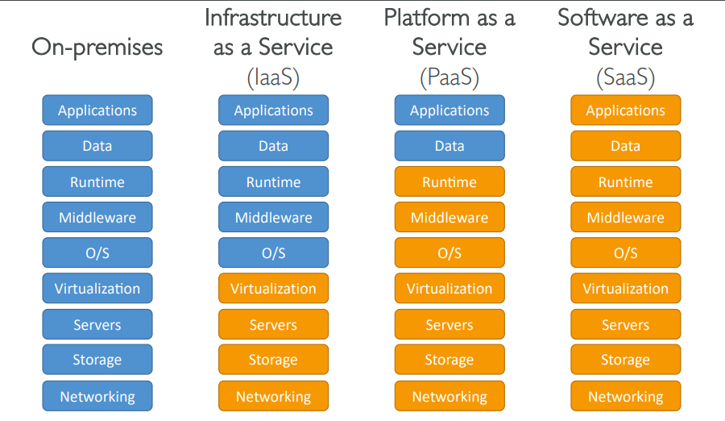

**AWS Global Infrastructure**

AWS divides the world into **Regions**, each containing multiple **Availability Zones (AZs)**.

* **Availability Zones** are separate data centers within a Region. They are isolated from each other to prevent disasters from affecting more than one zone. Each AZ has its own power, networking, and connectivity but is connected to other AZs with high-speed, low-latency networks. Examples of AZ names include ap-southeast-2a and ap-southeast-2b.
* **Regions** are groups of these AZs. AWS has Regions worldwide, such as us-east-1 and eu-west-3. Most AWS services are available within specific Regions, and some features may be limited to certain Regions initially.
* **Data Compliance**: Data doesn't leave a Region without your permission, ensuring compliance with legal and data governance requirements.
* **Proximity**: Regions are located close to customers to reduce latency, improving the speed and performance of services.
* **Service Availability**: Not all services or features are available in every Region immediately.
* **Pricing**: Costs can differ between Regions, and this information is available on AWS pricing pages.

<https://aws.amazon.com/about-aws/global-infrastructure/regions_az/>

**Steps to Create AWS Account**

The AWS Lift Program helps businesses start using AWS for their digital needs, offering access to over 200 services to improve agility and flexibility. By joining the program and spending at least $1 on AWS services, businesses receive $750 in promotional credits to begin using AWS. As the business grows, they can receive up to $83,500 in additional credits over 12 months. There are no long-term commitments or hidden fees, making it easy for businesses to start and expand their use of AWS services.

* 1. Enter Root user email address and Aws account name then click on verify email address.

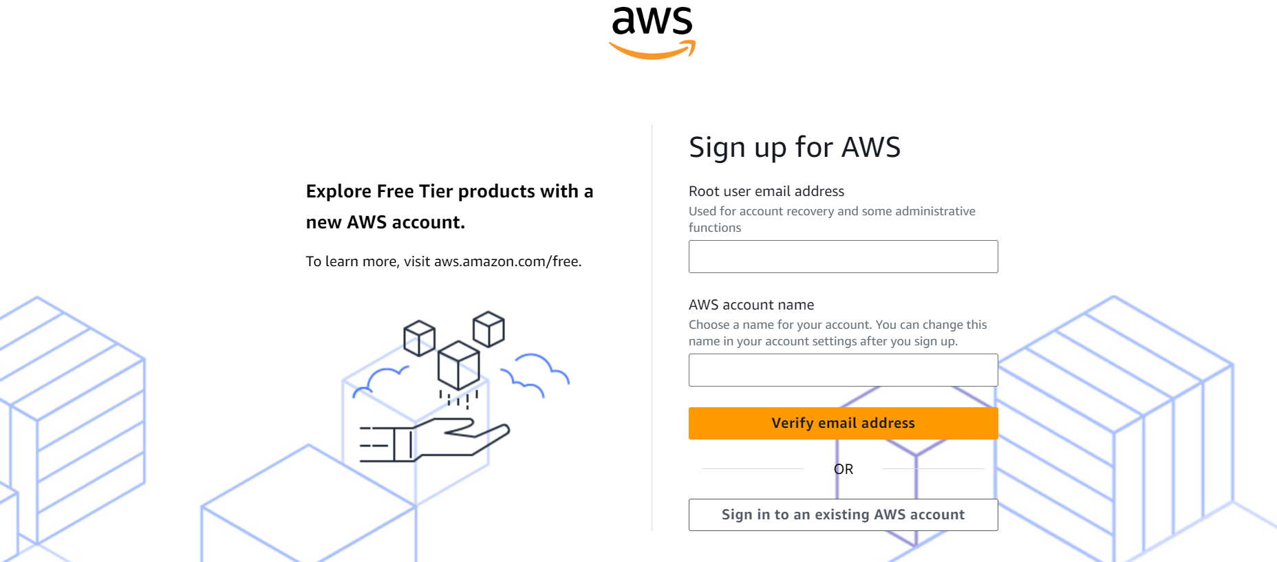

* 1. Enter verification code.

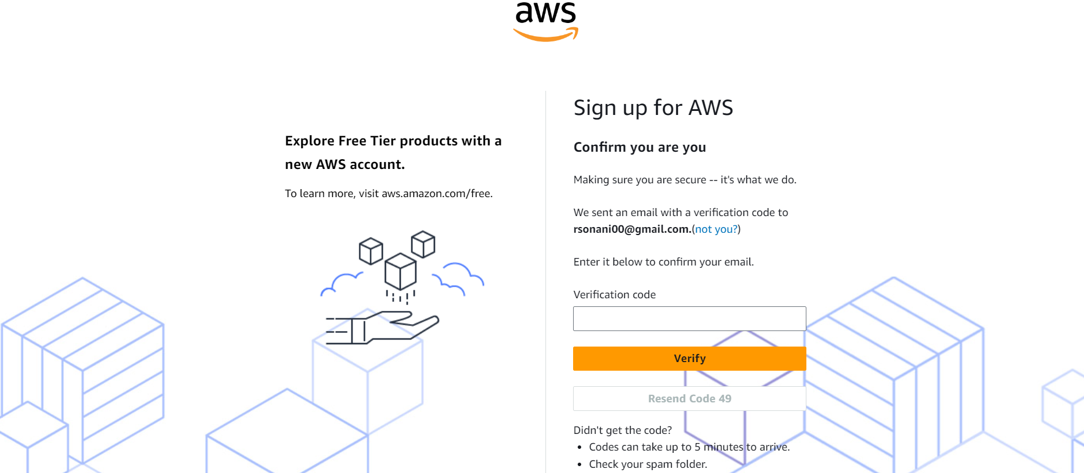

* 1. Set a Root user password.
  2. Enter All your contact information like fullname, phone no, Address etc..
  3. Enter Biling information at here must use credit card details.
  4. Verify your mobile no with OTP.
  5. Select support plan – Basic support Free and click on “Complete sign up” Button.